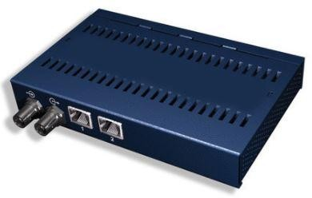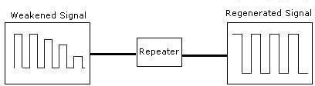

**EXP.NO.1A** STUDY OF NETWORKING DEVICES

# DATE: 14-8-2021

**AIM:**

To study the various networking devices in detail.

# Some of the networking devices:

1. Repeater.
2. Hub and its types.
3. Bridge and its types.
4. Switch.
5. Routers.
6. Gateway.
7. Brouter.

# REPEATER:

A repeater operates at the physical layer. Its job is to regenerate the signal over the same network before the signal becomes too weak or corrupted so as to extend the length to which the signal can be transmitted over the same network. An important point to be noted about repeaters is that they do not amplify the signal. When the signal becomes weak, they copy the signal bit by bit and regenerate it at the original strength. It is a 2 port device.

# HUB AND ITS TYPES:

When referring to a [network](https://www.computerhope.com/jargon/n/network.htm), a hub is the most basic networking [device](https://www.computerhope.com/jargon/d/device.htm) that connects multiple computers or other network devices.

Unlike network [switch](https://www.computerhope.com/jargon/s/switch.htm) or [router](https://www.computerhope.com/jargon/r/router.htm), a network hub has no [routing tables](https://www.computerhope.com/jargon/r/routing_table.htm) or Intelligence on where to send information and [broadcasts](https://www.computerhope.com/jargon/b/broadcas.htm) all network data across each connection.

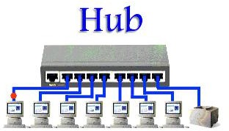

# TYPES OF HUB:

* 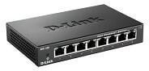**Active Hub:** These are the hubs which have their own power supply and can clean, boost and relay the signal along with the network. It serves both as a repeater as well as wiring center. These are used to extend the maximum distance between nodes.
* **Passive Hub:** These are the hubs which collect wiring from nodes and power supply from active hub. These hubs relay signals onto the network without cleaning and boosting them and can’t be used to extend the distance between nodes.
* **Intelligent Hub:** It work like active hubs and include remote management capabilities. They also provide flexible data rates to network devices. It also enables an administrator to monitor the traffic passing through the hub and to configure each port in the hub.

# BRIDGE AND ITS TYPES:

A bridge is a network device that connects multiple LANs (local area networks) together to form a larger LAN. The process of aggregating networks is called network bridging. A bridge connects the different components so that they appear as parts of a single network.

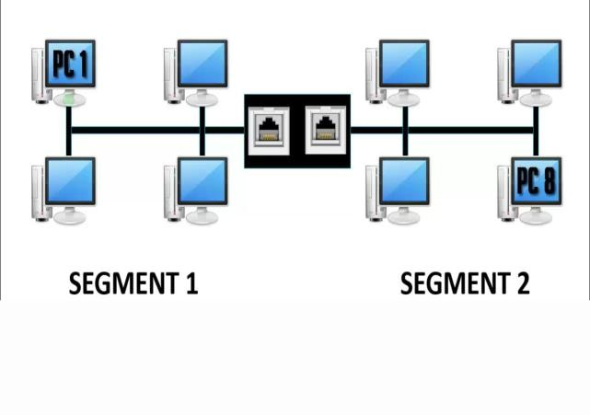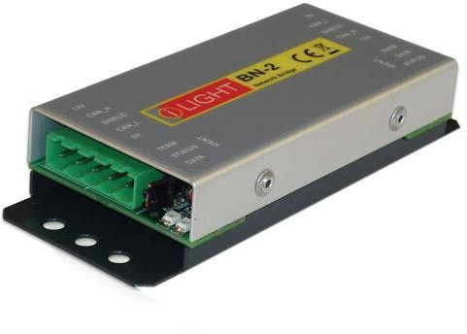

# TYPES OF BRIDGES:

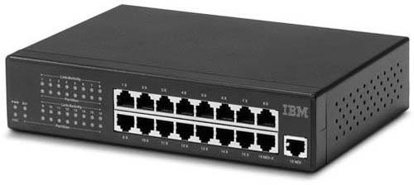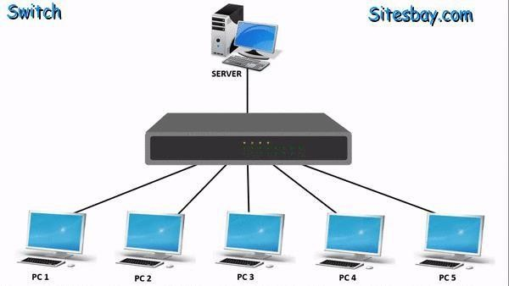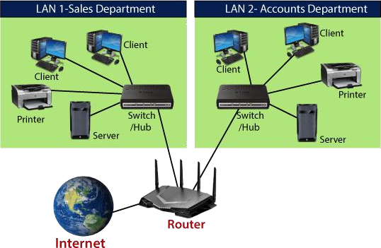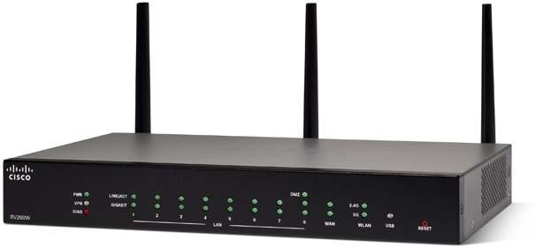

* **Transparent Bridges:** These are the bridge in which the stations are completely unaware of the

bridge’s existence i.e. whether or not a bridge is added or deleted from the network, reconfiguration of the stations is unnecessary. These bridges make use of two processes i.e. bridge forwarding and bridge learning.

* **Source Routing Bridges:** In these bridges, routing operation is performed by source station and the frame specifies which route to follow. The hot can discover frame by sending a special frame called discovery frame, which spreads through the entire network using all possible paths to destination.

# SWITCH:

A switch is a multiport bridge with a buffer and a design that can boost its efficiency (a large number of ports imply less traffic) and performance. A switch is a data link layer device. Theswitch can perform error checking before forwarding data that makes it very efficient as it does not forward packets that have errors and forward good packets selectively to correct portonly. In other words, switch divides collision domain of hosts, but broadcast domain remainssame.

# ROUTER:

A router is a device that connects two or more packet-switched networks or subnetworks. It serves two primary functions: managing traffic between these networks by forwarding [**data packets**](https://www.cloudflare.com/learning/network-layer/what-is-a-packet/) to their intended [**IP addresses**](https://www.cloudflare.com/learning/dns/glossary/what-is-my-ip-address/), and allowing multiple devices to use the sam Internetconnection.

# GATEWAY:

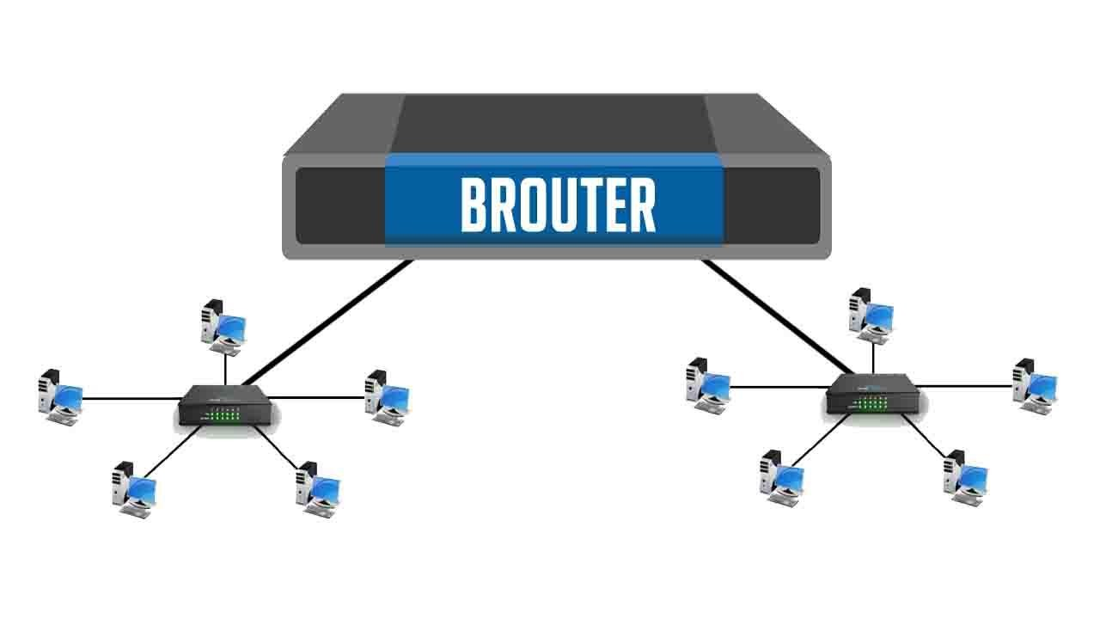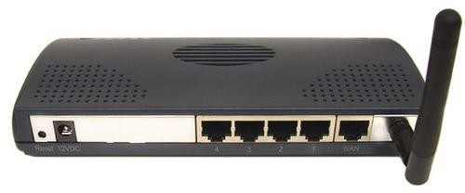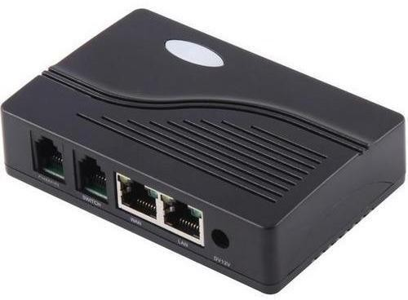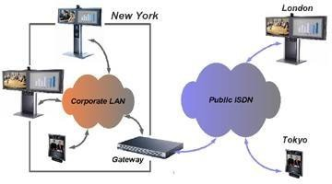

A gateway is a [**network node**](https://www.techtarget.com/searchnetworking/definition/node) used in telecommunications that connects two networks with different transmission [**protocols**](https://www.techtarget.com/searchnetworking/definition/protocol) together. Gateways serve as an entry and exit point for a

network as all data must pass through or communicate with the gateway prior to being routed.

# BROUTER:

A brouter is a device that functions as both a [bridge](https://techterms.com/definition/bridge) and a [router](https://techterms.com/definition/router). It can forward data between networks (serving as a bridge), but can also route data to individual systems within a [network](https://techterms.com/definition/network) (serving as a router).The main purpose of a bridge is to connect two separate networks. It simply forwards the incoming [packets](https://techterms.com/definition/packet) from one network to the next.

# RESULT:

Thus, the study on various networking devices in detail is done successfully.

# EXP.N0. 1B DATE: 14-8-2021

**AIM:**

To study about IP address, MAC address and PORT address.

# IP ADDRESS:

IP- Internet Protocol.

An IP address, or Internet Protocol address, is a series of numbers that identifies any device on a network. Computers use IP addresses to communicate with each other both over the internet as well as on other networks.

# Dotted Decimal Notation:

**Hexadecimal Notation:**

# Types of IP address:

* **IPv4(Internet Protocol version 4 )**

# IPv6(Internet Protocol version 6

[Internet Protocol version 4](https://en.wikipedia.org/wiki/IPv4) (IPv4) defines an IP address as a [32-bit](https://en.wikipedia.org/wiki/32-bit) number. However, because of the growth of the [Internet](https://en.wikipedia.org/wiki/Internet) and the [depletion of available IPv4 addresses,](https://en.wikipedia.org/wiki/IPv4_address_exhaustion) a new version of IP ([IPv6](https://en.wikipedia.org/wiki/IPv6)), using 128 bits for the IP address, was standardized in 1998. [IPv6](https://en.wikipedia.org/wiki/IPv6_deployment) [deployment](https://en.wikipedia.org/wiki/IPv6_deployment) has been ongoing since the mid-2000s.

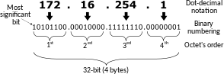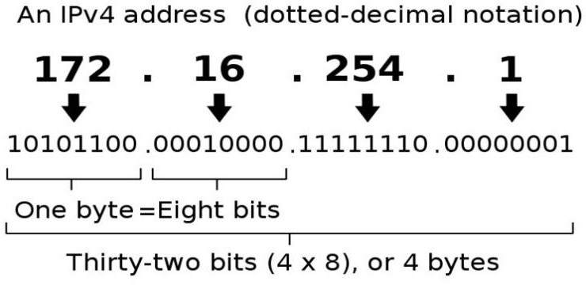

IP addresses are written and displayed in [human-readable](https://en.wikipedia.org/wiki/Human-readable) notations, such

as **172.16.254.1** in **IPv4**, and **2001:db8:0:1234:0:567:8:1** in **IPv6**.

# MAC ADDRESS:

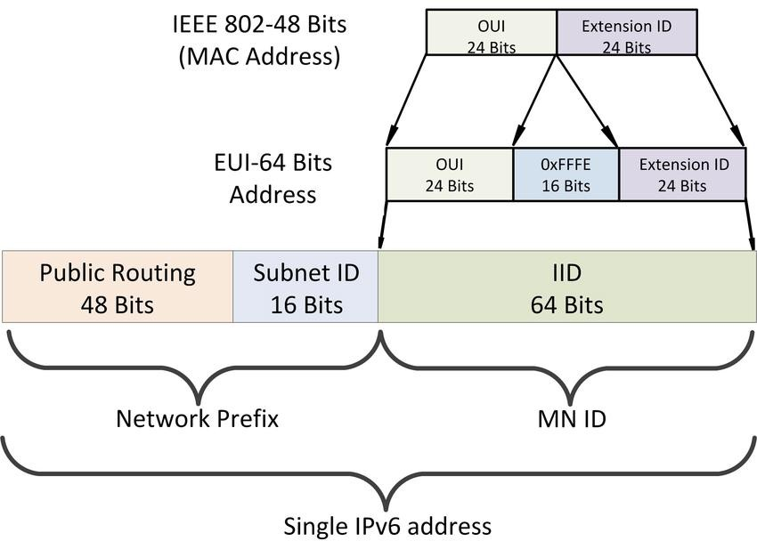

MAC-Media Access Control.

MAC Addresses are unique 48-bits hardware number of a computer, which is embedded into network card (known as Network Interface Card) during the time of manufacturing. MAC Address is also known as Physical Address of a network device. In IEEE 802 standard, Data Link Layer is divided into two sublayers –

* + Logical Link Control(LLC) Sublayer
  + Media Access Control(MAC) Sublayer

MAC address is used by Media Access Control (MAC) sublayer of Data-Link Layer. MAC Address is word wide unique, since millions of network devices exists and we need to uniquely identify each.

# Format of MAC Address

Traditional MAC addresses are 12-digit (6 [bytes](https://www.lifewire.com/the-difference-between-bits-and-bytes-816248) or 48 [bits](https://www.lifewire.com/definition-of-bit-816250)) [hexadecimal numbers](https://www.lifewire.com/what-is-hexadecimal-2625897). By convention, these addresses are usually written in one of the following three formats, although there are variations:

* MM:MM:MM:SS:SS:SS
* MM-MM-MM-SS-SS-SS
* MMM.MMM.SSS.SSS

The leftmost six digits (24 bits), called a prefix, are associated with the adapter manufacturer (M).

Each vendor registers and obtains MAC prefixes as assigned by the [IEEE](https://www.ieee.org/) Vendors often possess

# PORT ADDRESS:

A port number primarily aids in the transmission of data between a network and an application. Port numbers work in collaboration with networking protocols to achieve this. For example, in an incoming message/packet, the IP address is used to identify the destination computer/node, whereas

the port number further specifies the destination application/program in that computer. Similarly, all outgoing network packets contain application port numbers in the packet header to enable the receiver to distinguish the specific application. Port numbers are mainly used in TCP and UDP based networks, with an available range of 65,535 for assigning port numbers. Although an application

can change its port number, some commonly used Internet/network services are allocated with

global port numbers such as Port Number 80 for HTTP, 23 for Telnet and 25 for SMTP.

# Some common port numbers:

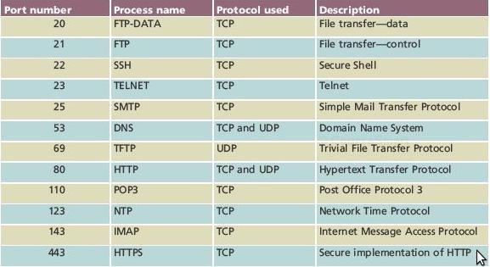

**RESULT:**

Thus, the study on various addresses is done successfully

# EXP.NO.2 DATE:

**AIM:**

# IMPLEMENTATION OF NETWORKING COMMANDS

To study the network configuration commands in detail.

# Networking Commands:

**COMMAND-1:** IPCONFIG

**DESCRIPTION:** command line tool used to control the network connections on Windows machines.

**SYNTAX:** ipconfig

**COMMAND-2:** PING command

**DESCRIPTION:** used as a simple way to verify that a computer can communicate over the [network](https://www.lifewire.com/what-is-computer-networking-816249) with another computer or network device.

**SYNTAX:** ping (a website name)**COMMAND-3:** TRACEROUTE command

**DESCRIPTION:** used to show several details about the path that a packet takes from the computer or device you're on to whatever destination you specify.

**SYNTAX:** tracert (destination address)

**COMMAND-4:** NETSTAT command

**DESCRIPTION:** generates displays that show network status and protocol statistics.

**SYNTAX:** netstat

**COMMAND-5:** NSLOOKUP command

**DESCRIPTION:** lets an Internet server administrator or any computer user enter

a [host](https://searchnetworking.techtarget.com/definition/host) name and find out the corresponding [IP address](https://searchwindevelopment.techtarget.com/definition/IP-address) or domain name system ([DNS](https://searchnetworking.techtarget.com/definition/domain-name-system)) record.

**SYNTAX:** nslookup (a website name)

# OUTPUT:

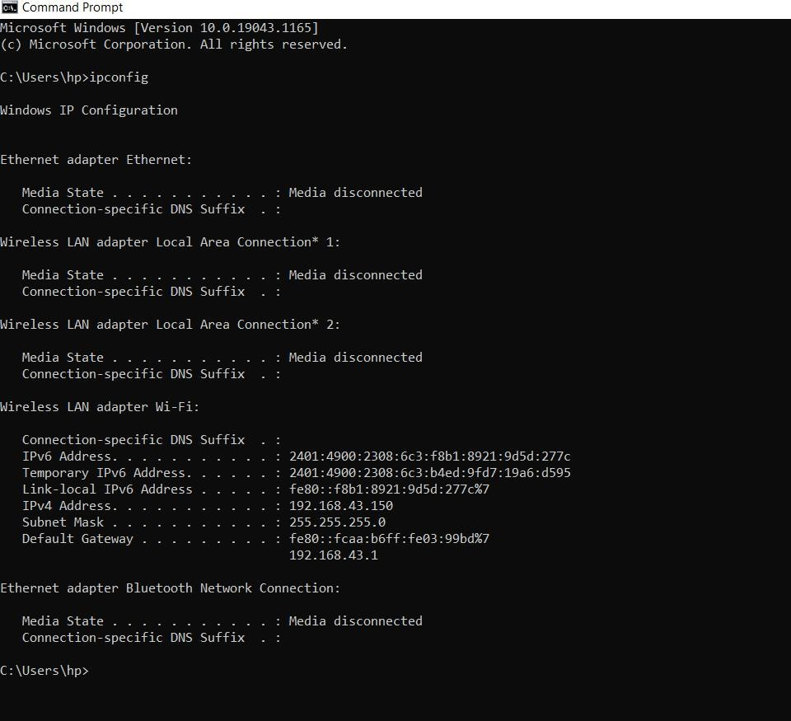

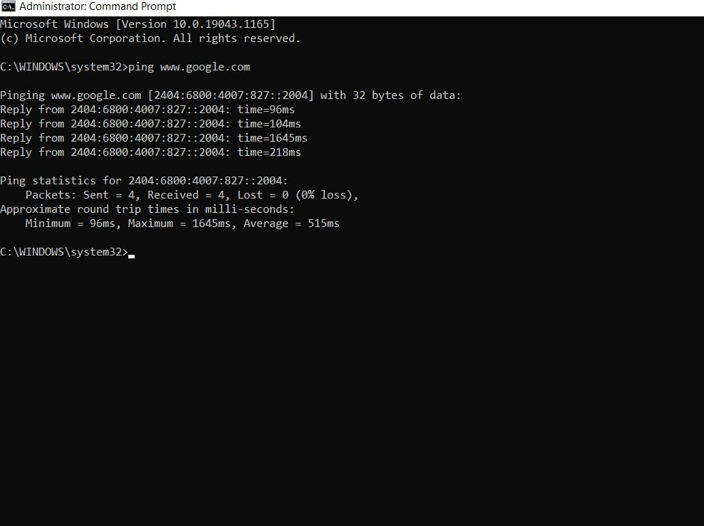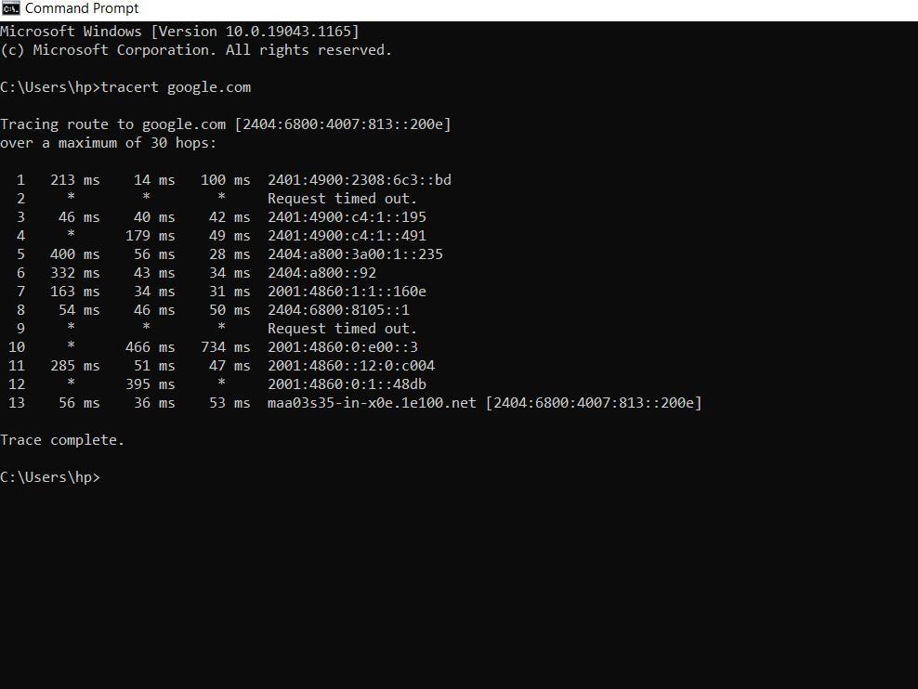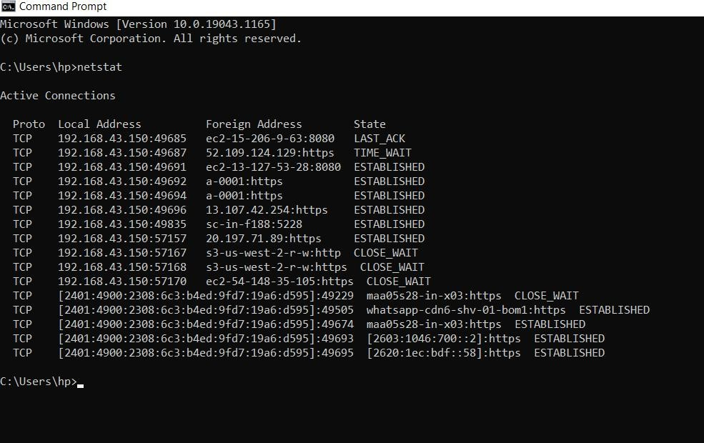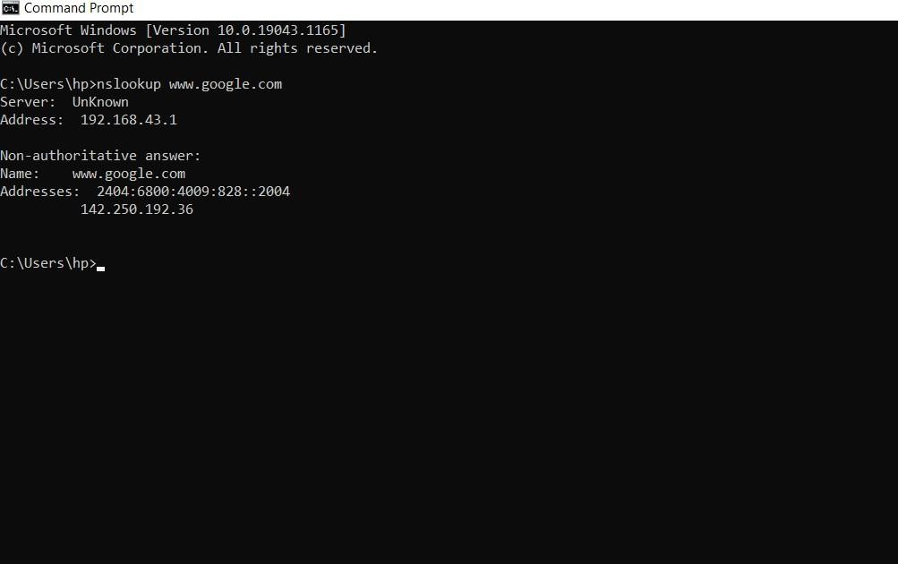

**RESULT:**

Thus, the above commands are executed successfully.